## Need for Speed

NOTE: You need a public class **Main**. Create the following **hierarchy** with the following **classes**: 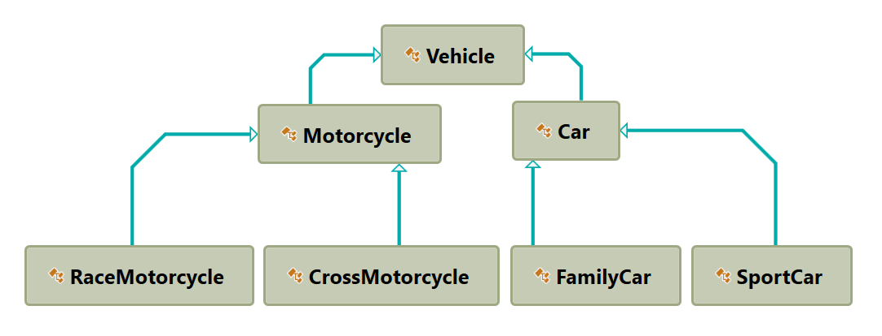

Create a base class Vehicle. It should contain the following members:

* **DEFAULT_FUEL_CONSUMPTION – final static double (constant)**
* **fuelConsumption –double**
* **fuel – double**
* **horsePower – int**
* **Getters and Setters for the fields**
* A public constructor which accepts (fuel, horsePower) and **set** the **default fuel consumption** on the field fuelConsumption
* **void drive(double kilometers)**
  + The **drive** method should have a functionality to reduce the **fuel** based on the travelled kilometers and fuel consumption. Keep in mind that you can drive the vehicle only if you have enough fuel to finish the driving.

The default fuel consumption for **Vehicle** is 1.25.Some of the classes have different default fuel consumption:

* **SportCar – DEFAULT_FUEL_CONSUMPTION = 10**
* **RaceMotorcycle – DEFAULT_FUEL_CONSUMPTION = 8**
* **Car – DEFAULT_FUEL_CONSUMPTION = 3**